Quantitative Module A

Decision-Making Tools

**Background**

The decision-making tools presented in this module are all relatively simple to apply, but at the same time, they can really help to facilitate logical thinking. The tools can be applied to many environments discussed in the textbook chapters.

An important assumption of decision trees is that they assume risk-neutral behavior. That is, the combination of alternatives that leads to highest expected monetary value will be chosen, regardless of potential risks of large losses. Instructors can allude to this assumption at various points in the lecture to explore under what conditions it may not make sense. They can mention that various approaches to incorporating risk are available. One idea is to create a utility function based on the decision maker’s risk preferences and then choose the combination of alternatives that maximize utility.

**Class Discussion Ideas**

1. Present a couple of ethical dilemmas (perhaps from earlier chapters in the text) and have a discussion about each. Then put Slide 35 (the decision tree for ethical dilemmas) on the screen and use it with the class to analyze the dilemmas. Did it help? Were any different conclusions drawn after using that decision tree?

**Active Classroom Learning Exercises**

1. Have the students develop a decision tree that models their educational options and decisions. Have them help you select two or three possible undergraduate majors with different earnings potentials. Give the students the options of pursuing graduate degrees, again with different earnings potentials. After one run through the numbers suggesting that all students should pursue graduate degrees, ask them why all students will actually *not* pursue graduate degrees. Different issues will arise, some of which may be able to be incorporated into the tree. Examples might include: “I’m sick of school,” “You forgot to include two years of forgone income plus the tuition expense of graduate school,” “My girlfriend will leave me and I won’t be able to marry her so I’ll lose all of her potential income,” “Too many people have graduate degrees now, so they have lost their luster,” “I don’t want to maximize my future wealth—I’m all about work-life balance,” etc.

**Presentation Slides**

INTRODUCTION (A-1 through A-7)

Slide 7: Module A opens with this high-stakes poker decision. Poker has become particularly popular in recent years, so many students will be able to relate well to the example. The decision is shown in this slide, and the actual calculations and results from the real event are shown in Slide 36.

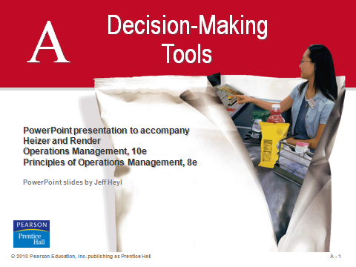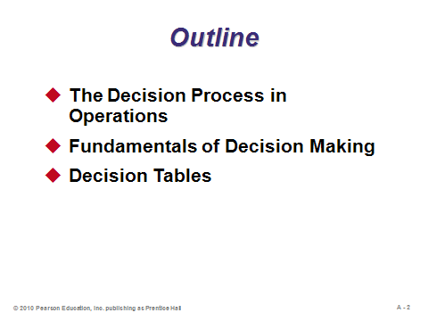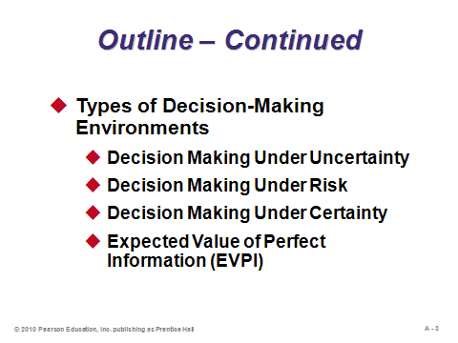

**A-1 A-2 A-3**

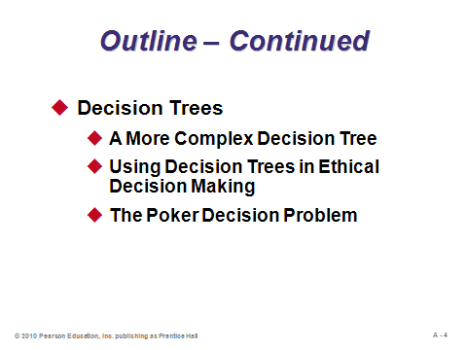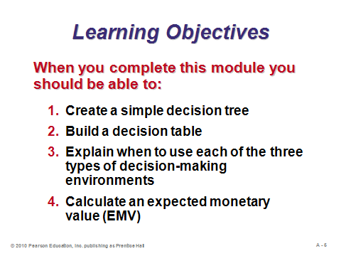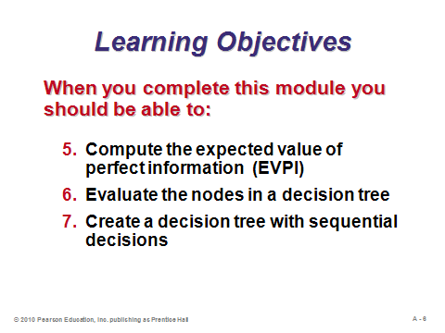

**A-4 A-5 A-6**

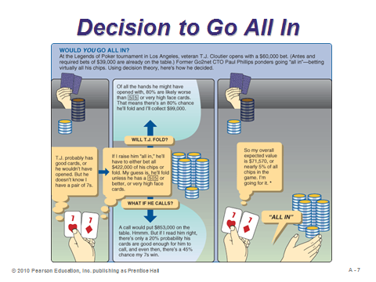

**A-7**

THE DECISION PROCESS IN OPERATIONS (A-8)

Slide 8: To a great extent, the success or failure of both people and companies depends on the quality of their decisions. Good decisions are based on logic and consider all available data and possible alternatives. They also follow the six steps identified in this slide.

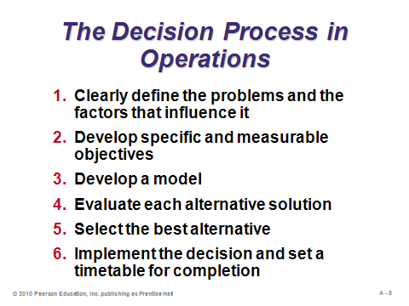

**A-8**

FUNDAMENTALS OF DECISION MAKING (A-9 through A-11)

Slides 9-11: Decision theory involves deciders making decisions (among *alternatives* using a square node in a decision tree) and considering various *states of nature* (using a circle in a decision tree) such as the weather, the state of the economy, or the outcome of a football game. Slide 11 (Example A1) presents a simple decision tree for a firm, Getz, considering whether or not to build either a large or small plant.

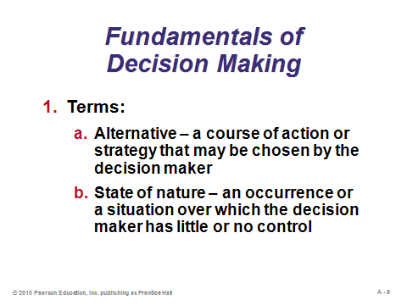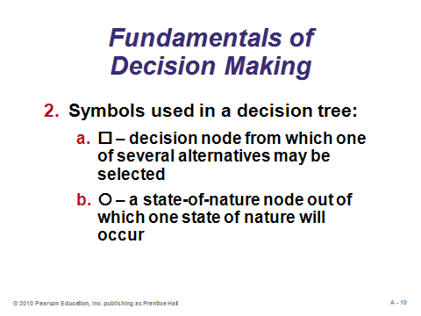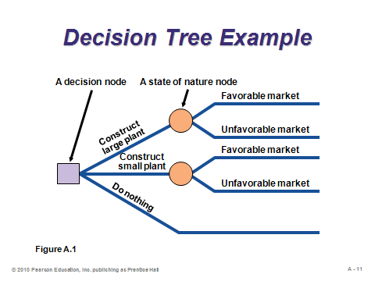

**A-9 A-10 A-11**

DECISION TABLES (A-12)

Slide 12: A *decision table* or *payoff table* presents the *conditional values*, or payoffs (usually expressed in monetary value) for combinations of alternatives (down the rows) and states of nature (across the columns). This slide presents the decision table from Example A2, which continues the Getz decision.

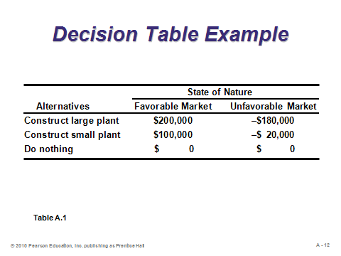

**A-12**

TYPES OF DECISION-MAKING ENVIRONMENTS (A-13 through A-25)

Slide 13: The three decision-making environments are identified in Slide 13.

Slides 14-17: These slides describe three methods that can be applied to decision making under *uncertainty*, when the decider cannot assign probabilities to the states of nature. The *maximax* approach (Slide 14) is completely optimistic, searching only for the best payoff in the decision table and selecting the associated alternative with no regard to any other potential outcomes for that alternative. *Maximin* (Slide 15) is a pessimistic approach, looking at the worst possible outcome for every alternative and choosing the alternative whose worst outcome is best. The *equally likely* approach (Slide 16) assumes that each state of nature has the same probability of occurring, so a simple average of possible payoffs for each alternative is computed and the alternative with the best average is chosen. Slide 17 (Example A3) analyzes the Getz decision according to all three methods. For this example, each of the three alternatives was chosen, depending on the method used. See OTHER SUPPLEMENTARY MATERIAL below for a description of two more methods.

Slides 18-21: These slides describe decision making under *risk*, when the decider can assign probabilities to the states of nature. The states of nature need to be mutually exclusive, and their respective probabilities need to sum to 1 (Slide 18). Slide 19 shows how to compute the *expected monetary value* (EMV) for each alternative, which is simply the expected value (weighted average) of the payoffs over the possible states of nature. Slides 20 and 21 (Example A4) compute the EMVs for each alternative in the Getz decision. The small plant decision has the highest EMV.

Slides 22-25: These slides describe decision making under *certainty*, when the decider knows ahead of time which states of nature will occur. This application arises most often when a firm can pay a fee to require some sort of market analysis or other research that purports to be able to predict future states of nature with certainty. (In the stock market world, certain apparently prophetic investment analysts receive lots of attention during bull markets but tend to disappear during bear markets.) The *expected value of perfect information* (EVPI) determines an upper limit on the amount that a firm should be willing to spend to receive a perfect forecast (Slide 22). The formula is presented in Slide 23, and it incorporates the *expected value with perfect information* (EVwPI). The EVwPI calculation grabs the best possible payoff for each state of nature, under the assumption that if the firm knows ahead of time what the state of nature will be, then the firm will choose the best alternative for that particular state. Slides 24 and 25 (Example A5) extend the Getz example to calculate the EVPI. As an aside, texts on decision theory or management science sometimes describe the *expected value of sample information*, which incorporates Bayesian analysis applied to *imperfect* market research.

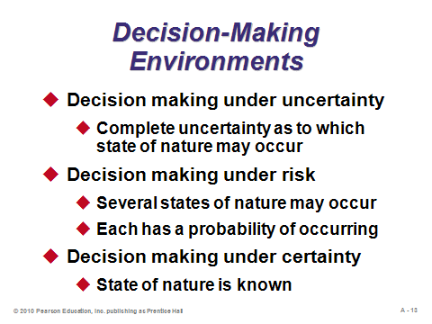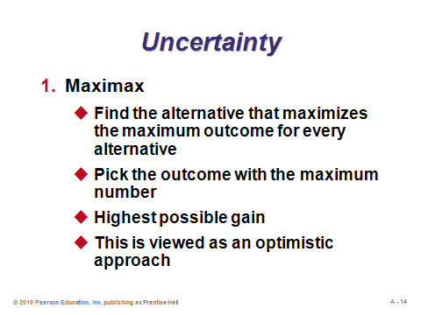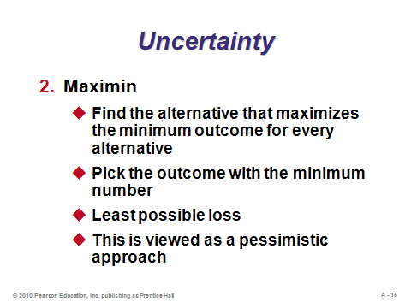

**A-13 A-14 A-15**

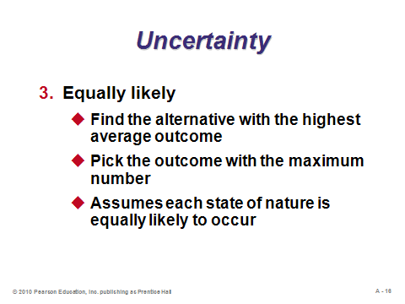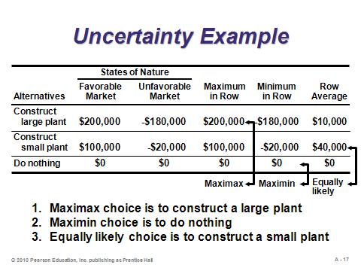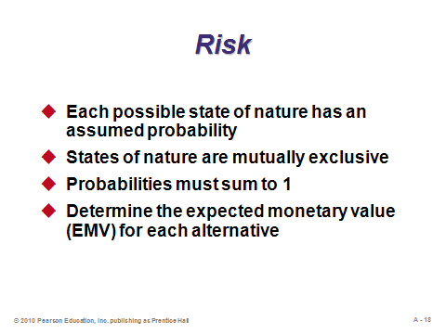

**A-16 A-17 A-18**

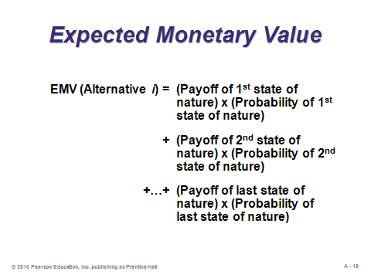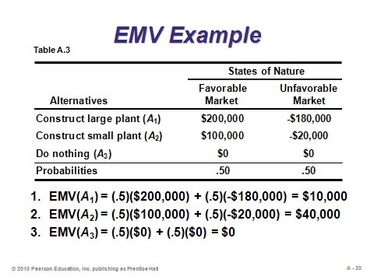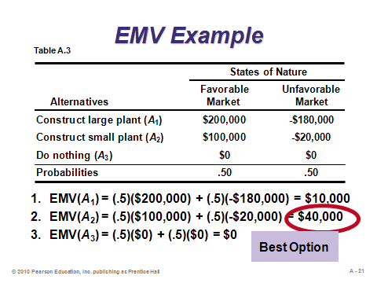

**A-19 A-20 A-21**

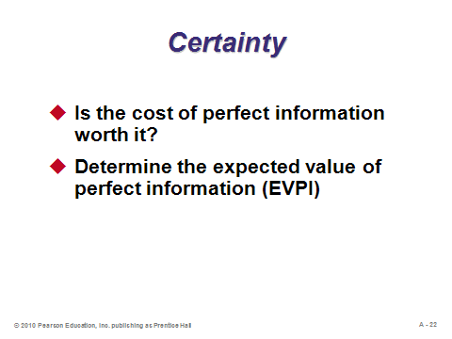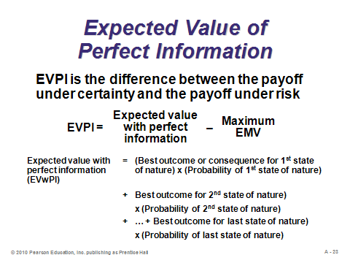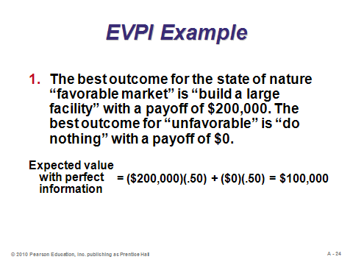

**A-22 A-23 A-24**

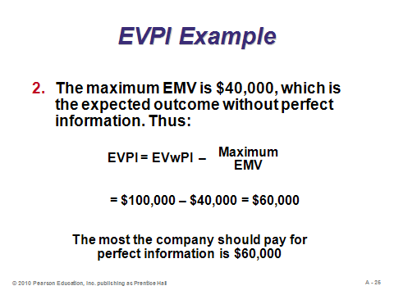

**A-25**

DECISION TREES (A-26 through A-36)

Slides 26-29: Decision trees are particularly useful tools for analyzing *sequential* decisions (for example, whether or not to attend college, and then if attending, which major to choose). They not only display all of the information contained in a decision table, but probabilities and expected value amounts can be inserted along the way to clearly indicate the best choices to make at each decision node. Slide 28 identifies the five steps in analyzing problems with decision trees. Slide 29 (Example A6) solves the Getz problem using a decision tree. A decision tree indicates the alternatives that combine to produce the best overall final EMV.

Slides 30-33: These slides (Example A7) present a more complex decision tree example that includes sequential decisions. In particular, Getz has the option of conducting a $10,000 market survey. The survey results will not be perfect, but they will improve the probability estimates for favorable and unfavorable markets (these are called *conditional* probabilities). In this example, since the EMV with the market survey is $9,200 higher than without the survey, the survey should be conducted. If the survey results are favorable, a large plant should be built; however, if the survey results are unfavorable, a small plant should be built.

Slides 34-35: The decision tree shown in Slide 35 (Figure A.4) provides guidance as to how managers can both maximize shareholder value and behave ethically.

Slide 36: The calculations for the poker decision problem from Slide 7 are presented in this slide (Example A9), based on expected monetary value. Even though the player actually lost the hand, he made the proper decision based on EMV. This can be a good point in the lecture to bring up the point that EMV assumes risk-neutral behavior. In fact, most poker players are arguably either risk-averse or risk-loving. The incorporation of risk preference is left to books on decision theory and economics.

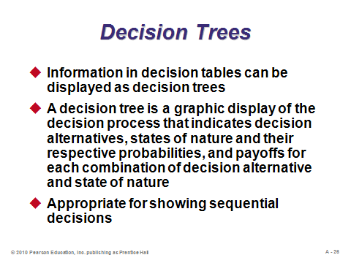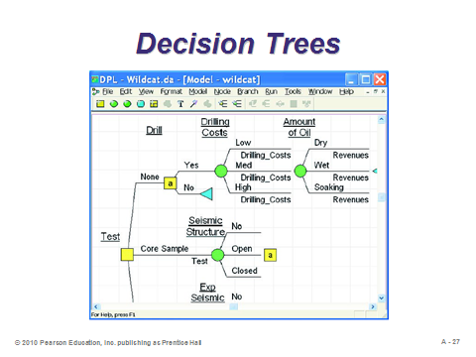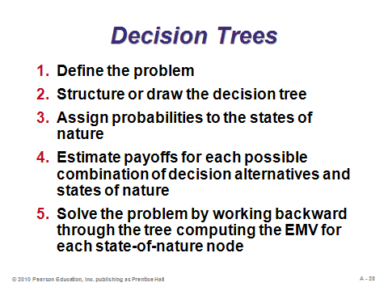

**A-26 A-27 A-28**

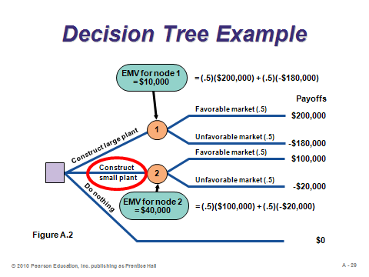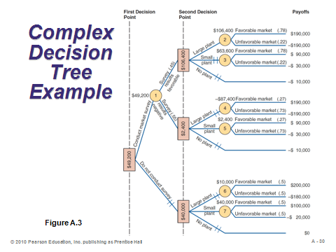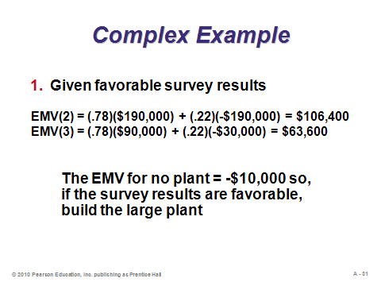

**A-29 A-30 A-31**

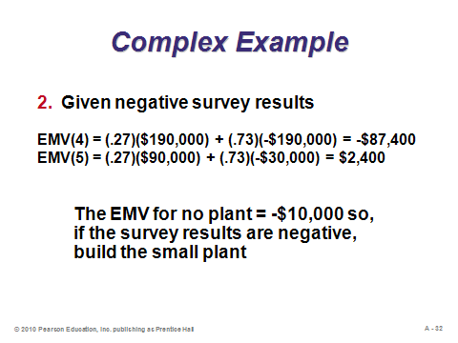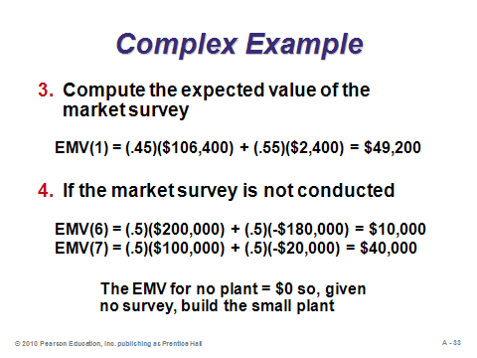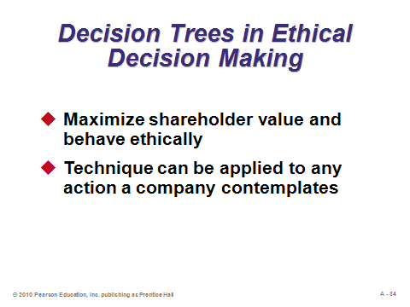

**A-32 A-33 A-34**

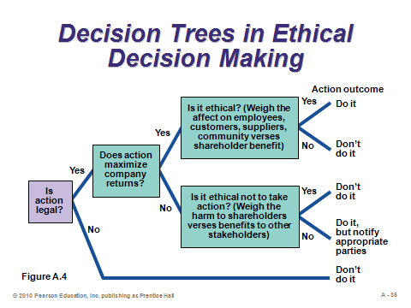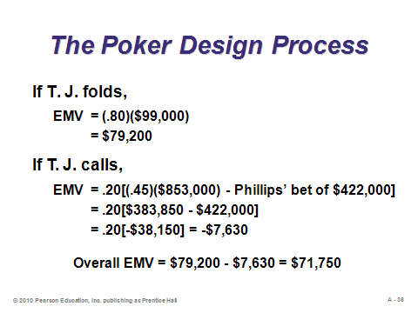

**A-35 A-36**

**Additional Assignment Ideas**

1. Visit the Web sites of two decision-tree software products and describe the features. Provide screen captures with the report. Here are two possible starting places:

* + http://www.treeage.com
* http://www.palisade.com.au/precisiontree/

**Additional Case Studies**

Internet Case Study (www.pearsonhighered.com/heizer)

* *Arctic, Inc*.: A refrigeration company has several major options with regard to capacity and expansion.

Richard Ivey School of Business (http://cases.ivey.uwo.ca/cases/pages/home.aspx)

* *Lockhurst Hotels International* (9A83D004): The vice-president of Canadian operations of Lockhurst Hotels International is faced the following decision. His director of Ontario operations had received an offer of employment with another hotel chain at an increase in salary of $15,000 per year. The VP wondered what action, if any, he should take.

**Other Supplementary Material**

Other Methods for Decision Making under Uncertainty

1. *The Hurwicz Criterion*

Maximax is purely optimistic while maximin is purely pessimistic. But what if the decision maker is somewhere in between? The Hurwicz criterion tries to provide a balance.

Determine a *coefficient of optimism* α, which lies between 0 and 1. For each row in the payoff table, compute α times the maximum payoff plus (1 – α) times the minimum payoff. Choose the alternative yielding the best (maximum) of these Hurwicz calculations.

Higher values of α implies that the decision maker is “more optimistic.” The Hurwicz criterion is equivalent to maximin when α = 0 and maximax when α = 1. A “half-optimistic” decision maker would use α = 0.5.

2. *Minimax Regret*

This method is slightly more involved than most other methods for decision making with uncertainty. This approach appeals to the decision maker who does not want to feel too bad (regretful) afterwards about whatever decision was made.

The first step is to create a new parallel table called a *regret table*. The table computes the opportunity cost for each alternative under each state of nature. The regret in any cell equals the best possible payoff from that column in the payoff table minus the payoff of that particular alternative. (The best alternative for a particular state of nature will have a regret of 0 in its cell.) After the regret table is created, find the maximum regret in each row. Finally, choose the alternative that has the smallest of these maximum regrets.

Minimax regret represents an attempt at providing a *robust* solution that will never perform too badly, no matter what the outcome.